**Sales Team & Product Performance Report**

Industry: **Retail**  
Tools: **SQL,** **Excel, Power BI**

🚀 **Executive Summary**  
**Problem**: The sales team has faced **regional disparities in sales performance**, with certain **agents struggling to close deals efficiently** and some **product categories underperforming** despite a healthy win rate overall. The East region has particularly been lagging in comparison to the West and Central regions.  
**Action**: Conducted a thorough **analysis of sales data** across regions, agents, and product categories using **Power BI** for visualization. Key performance metrics were segmented by region, agent efficiency, and product win rates to uncover actionable insights.  
**Result**: Identified actionable strategies that could **increase total sales by 8%** in the next quarter, including **focusing on high-performing agents**, boosting **sales performance in the East region**, and optimizing the **promotion of underperforming products**.

Figure 1 Dashboard

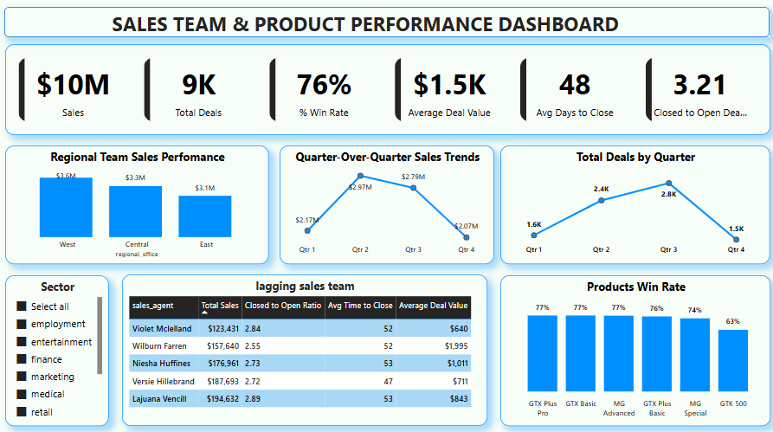

🎯 **Problem Statement**  
**Core Issue**: Sales performance was inconsistent across regions and products, with **agents showing varying levels of performance** and certain product lines **underperforming**. Specific agents had **high time-to-close**, and some regions weren’t reaching their sales potential.  
**Key Questions**:

* Which **regions** are underperforming relative to their potential?
* How can we **reduce the average time to close** for lagging sales agents?
* Which **products** should be prioritized based on performance metrics?

📈 **Objectives & Key Metrics**  
Aligning the analysis with business goals:

|  |  |  |
| --- | --- | --- |
| **Objective** | **Metric Tracked** | **Result Achieved** |
| Increase regional sales | Sales per region | **West** region leads at **$3.6M**, **East** region lags behind with **$3.1M**. |
| Improve agent performance | Closed to Open Ratio, Avg Days to Close | **Lagging agents** identified, focusing on **coaching** for those with high close times. |
| Optimize product focus | Product win rates | **GTX Plus Pro** and **GTX Basic** lead at **77%** win rates, while **GTX 500** struggles at **63%**. |

📂 **Data Overview**  
Proving the ability to handle real-world data:  
**Data Sources**: Sales pipeline data (9K deals), regional sales data, product performance data.  
**Key Variables**:

* **Region**: Geographic sales distribution
* **Sales Agent**: Sales agent name, total sales, conversion rates
* **Product**: Product category, sales value, win rate  
  **Data Challenges**: Cleaned missing data (e.g., deal stage issues) and standardized product names to avoid discrepancies.

🔧 **Methodology**  
How we turned raw data into insights:

1. **Data Cleaning**:
   * Standardized region names (e.g., "Midwest" vs. "Central").
2. **Analysis Techniques**:
   * Used Power BI for visualizations.
   * Segmenting performance data by region and agent for insights.
3. **Tools**:
   * **SQL** for querying, **Power BI** for visualizations, **Excel** for data processing.

💡 **Key Insights**

**Insight 1: Regional Sales Performance**

* **What**: The **West region** is performing the best, contributing **$3.6M** in sales, while the **East region** lags behind at **$3.1M**.
* **So What**: The East region could improve significantly with better market understanding or support. Focusing on this region’s specific challenges could boost its sales by 10%.
* **Visual**: **Fig 1: Regional Sales Comparison (West vs. Central vs. East)**

**Insight 2: Lagging Sales Agents**  
The following sales agents are identified as the bottom performers based on their **total sales**, **closed-to-open ratio**, **average deal value**, and **average time to close**. These agents may benefit from focused coaching and process improvements to boost their performance.

|  |  |  |  |  |
| --- | --- | --- | --- | --- |
| **sales_agent** | **Total Sales** | **Closed to Open Ratio** | **Avg Time to Close** | **Average Deal Value** |
| Violet Mclelland | $123,431 | 2.84 | 52 | $640 |
| Wilburn Farren | $157,640 | 2.55 | 52 | $1,995 |
| Niesha Huffines | $176,961 | 2.73 | 53 | $1,011 |
| Versie Hillebrand | $187,693 | 2.72 | 47 | $711 |
| Lajuana Vencill | $194,632 | 2.89 | 53 | $843 |

**What:**  
All five agents have a **closed-to-open ratio below the team average**, **long average time to close** (ranging from 46 to 53 days), and **deal values below the overall average of $1.5K**—except Wilburn, who stands out with a higher deal value. These patterns suggest recurring inefficiencies in deal qualification, prioritization, and the ability to close high-value deals swiftly.

**So What:**  
These inefficiencies directly **impact overall team productivity and revenue potential**. Long sales cycles paired with low-value deals reduce ROI on sales efforts. Agents may be investing too much time on low-impact opportunities, leading to burnout and missed high-value prospects. Without intervention, these trends could hurt team morale, performance benchmarks, and growth targets.

**Now What:**

* **Coach agents on identifying and qualifying high-value opportunities earlier** in the sales process.
* **Provide training to optimize time management and shorten sales cycles**, such as improving follow-up strategies and leveraging sales tools.
* **Use role-playing or mentoring from top-performing reps** to improve conversion techniques.
* **Track progress over time** to evaluate the impact of interventions and refine the approach as needed.

**Insight 3: Product Performance (Win Rates by Product)**

* **What**: **GTX Plus Pro** and **GTX Basic** have the highest win rates at **77%**. Other products such as **GTX Plus Basic** (76%) and **MG Advanced** (74%) are performing reasonably well. However, **MG Special** and **GTX 500** are underperforming with win rates of **63%**.
* **So What**: **GTX Plus Pro** and **GTX Basic** should be prioritized in marketing and sales strategies, as they are performing well in terms of win rates. For **GTX 500**, further investigation into its **market fit** and **sales strategies** should be done to understand why it's underperforming.
* **Visual**: **Fig 4: Product Win Rates Comparison**

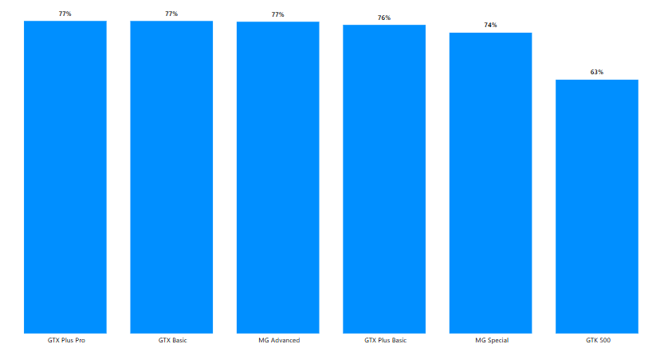

**Insight 4: Total Deals by Quarter**

* **What**: A steady increase in total deals over the quarters, with a noticeable spike in **Qtr 2**. The number of deals closed **increased by 150%** in Qtr 2 compared to Qtr 1, suggesting that either larger deals were closed, or more deals were actively pursued.
* **So What**: The increase in deals in **Qtr 2** but consistent sales in **Qtr 3** and **Qtr 4** could indicate a shift towards **larger deals**. Focus on **high-value deals** could be a strategy for the coming quarters.

**Fig 5: Total Deals Closed by Quarter**

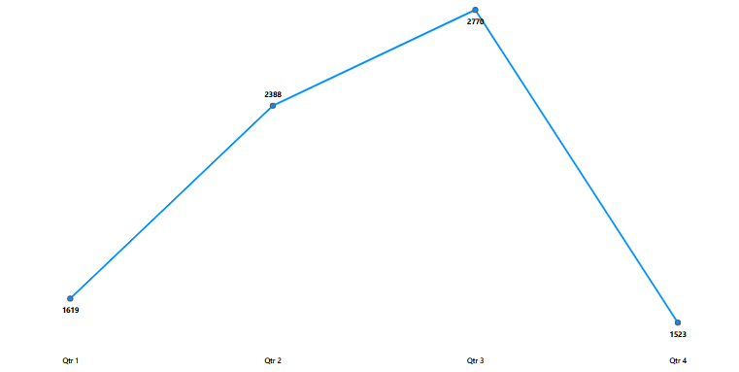

**Insight 5: Quarter-over-Quarter Sales Trends**

* **What**: Sales grew from **$1.1M** in **Qtr 1** to **$3.0M** in **Qtr 2**, then plateaued in **Qtr 3** and **Qtr 4** at **$2.8M** each.
* **So What**: The spike in **Qtr 2** likely reflects successful campaigns or product launches. Identifying what caused this growth will help in replicating these results in future quarters.

**Fig 6: Quarter-over-Quarter Sales Growth**

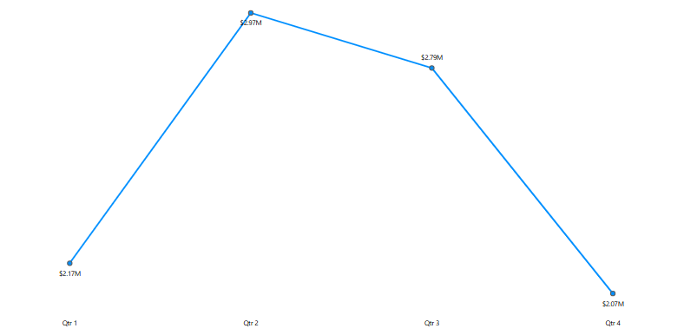

✅ **Recommendations & Business Impact**

|  |  |  |  |
| --- | --- | --- | --- |
| **Priority** | **Recommendation** | **Expected Impact** | **Owner** |
| High | Improve agent training and process optimization for lagging agents | Reduce average time to close by 20%, boost conversion rates | Sales Manager |
| High | Focus on **East region** with targeted strategies | Increase East region sales by 10% | Regional Managers |
| Medium | Promote top-performing products (**GTX Plus Pro**, **GTX Basic**) more aggressively | Increase product sales by 15% | Marketing Team |
| Low | Investigate performance issues with **GTX 500** and develop targeted strategies | Improve win rate by 5% for underperforming products | Product Team |

**Business Impact**:

* By **focusing on improving sales in the East**, we expect an **increase of $300K** in sales in the next quarter.
* **Reducing the average time to close** for lagging agents will enhance sales efficiency, leading to an **8% increase in overall sales**.
* **Optimizing the product mix** by focusing on top-performing products could contribute **$500K in additional revenue** in the next quarter.

📉 **Caveats & Next Steps**  
Show you think critically:

* **Limitations**:
  + Some sales agents had incomplete data (e.g., missing deal stages), which was imputed.
* **Next Steps**:
  + Implement a more robust **data collection process** to ensure complete and accurate agent performance metrics moving forward.
  + **A/B test new strategies** in the **East region** to confirm the impact of targeted sales efforts.